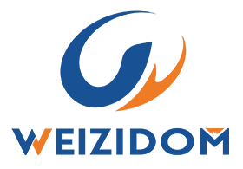
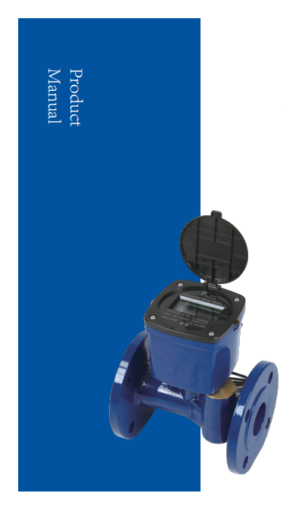
TS18
Ultrasonic
Water Meter
Manual Product
Innovating Measurement Professional Smart
Meter Manufacturer

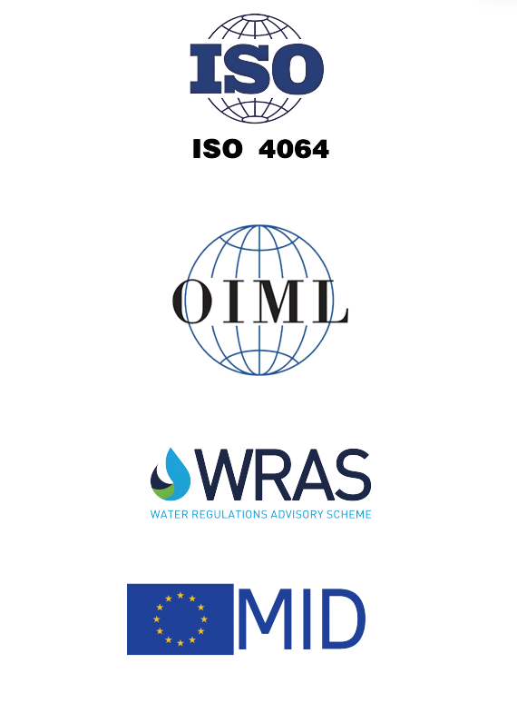

Basic Information

TS8 is an advanced electronic ultrasonic water meter with large caliber and high precision. It is a metering instrument that uses the ultrasonic time-difference method to continuously measure, record, and display the volume of water flowing through the sensor. It can meet the strict requirements of water metering management departments for accurate measurement of water consumption. The TS8 ultrasonic metering water meter is compatible with IoT transmission technology, providing users with different customized solutions. It is widely used in water supply main lines, agricultural irrigation, industrial water use and other fields.
.No moving parts in the measuring mechanism, no wear, and the accuracy will not decrease during the service life of the meter;
.Supports 9-digit LCD display;
.Supports vertical/horizontal or inclined installation angles;
.Supports reverse flow detection for accurate measurement;
.Supports non-full pipe detection;
.Low pressure loss;
.IP68 protection level, adaptable to various harsh installation environments;
.Supports remote reading of meter data: wired reading via RS-485/M-Bus/pulse, wireless reading via LoRa/LoRaWAN/W-MBUS/NB-IoT.
Product Disassembly
1 Non-full Pipe Alarm
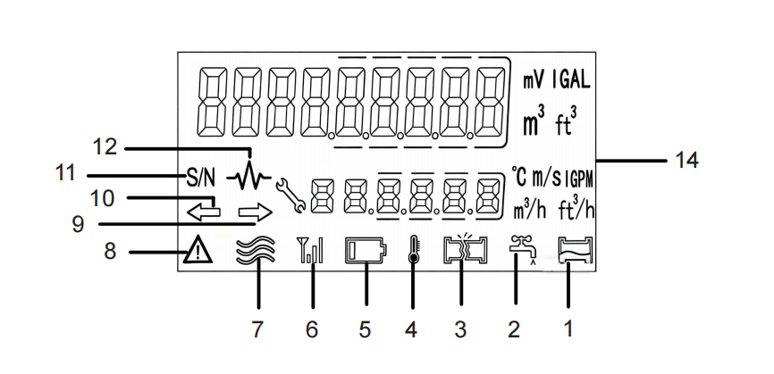
2 Drip/Leakage Alarm
3 Burst Pipe Alarm
4 Temperature Indicator
5 Low Pressure Alarm
6 Signal Strength 12
7 Water Flow Status Indicator
8 Fault/Alarm Indicator 8
9 Forward Flow Indicator
10 Reverse Flow Indicator
11 Meter Address
12 Signal Amplitude
13 Unit

Nameplate
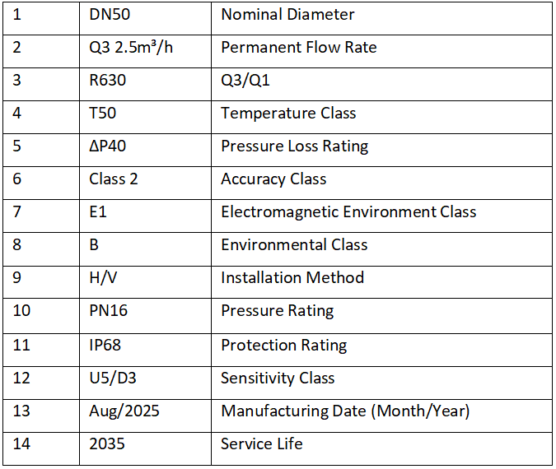
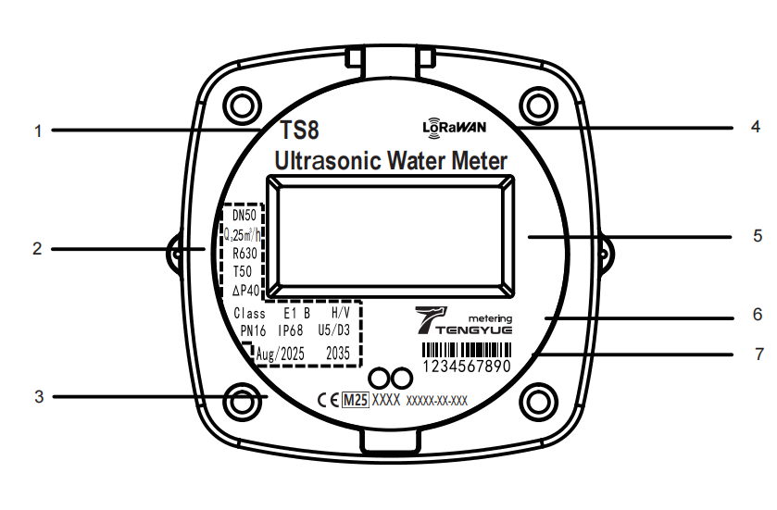
1 Model
2 Specifications / Meter Parameters
3 Certification Mark
4 Communication Method / Protocol
5 LCD Display Area
6 Manufacturer/Company Logo
7 Meter Address

Technical Specifications
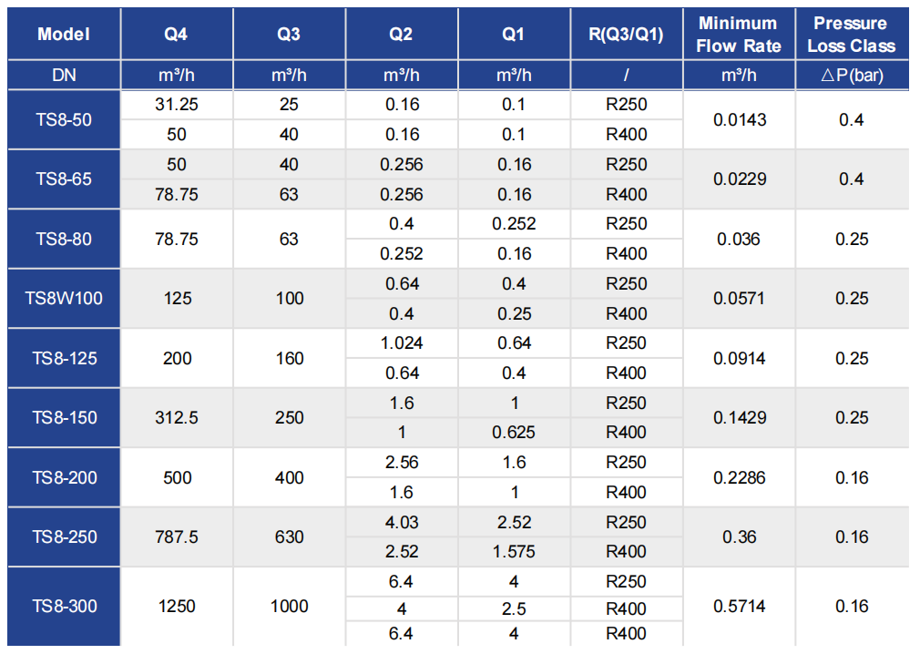
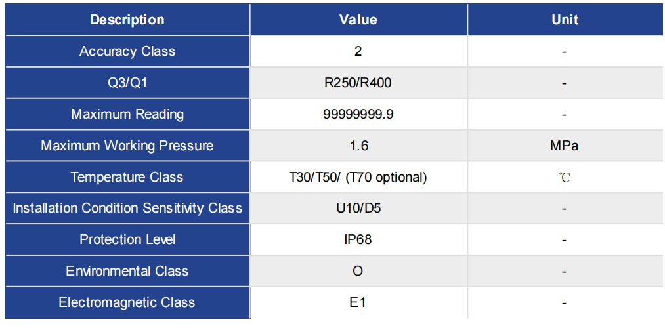

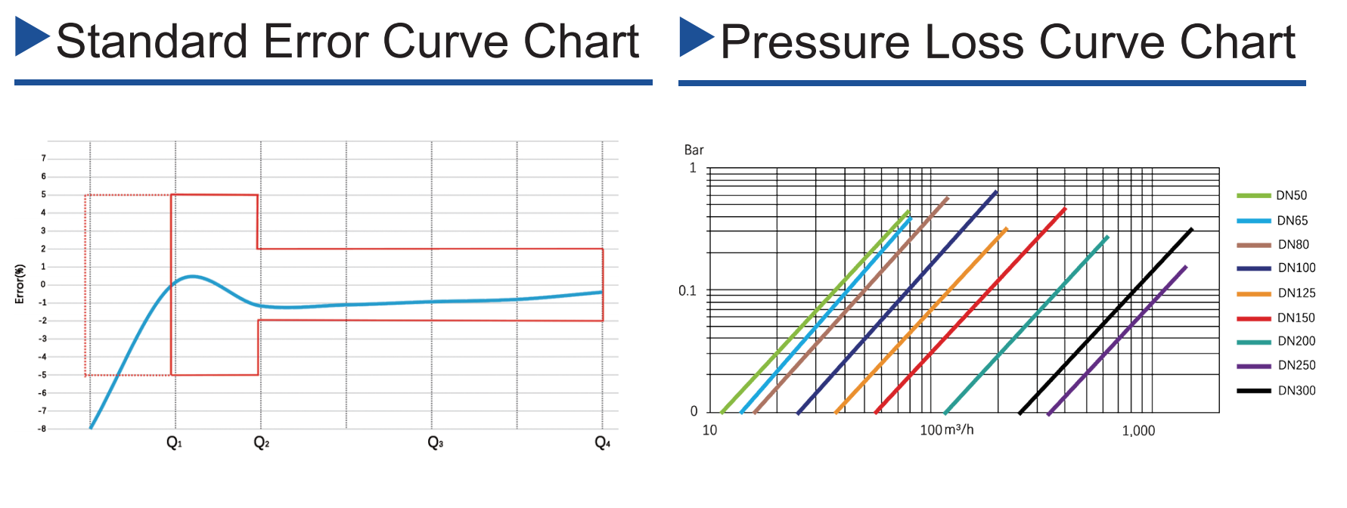
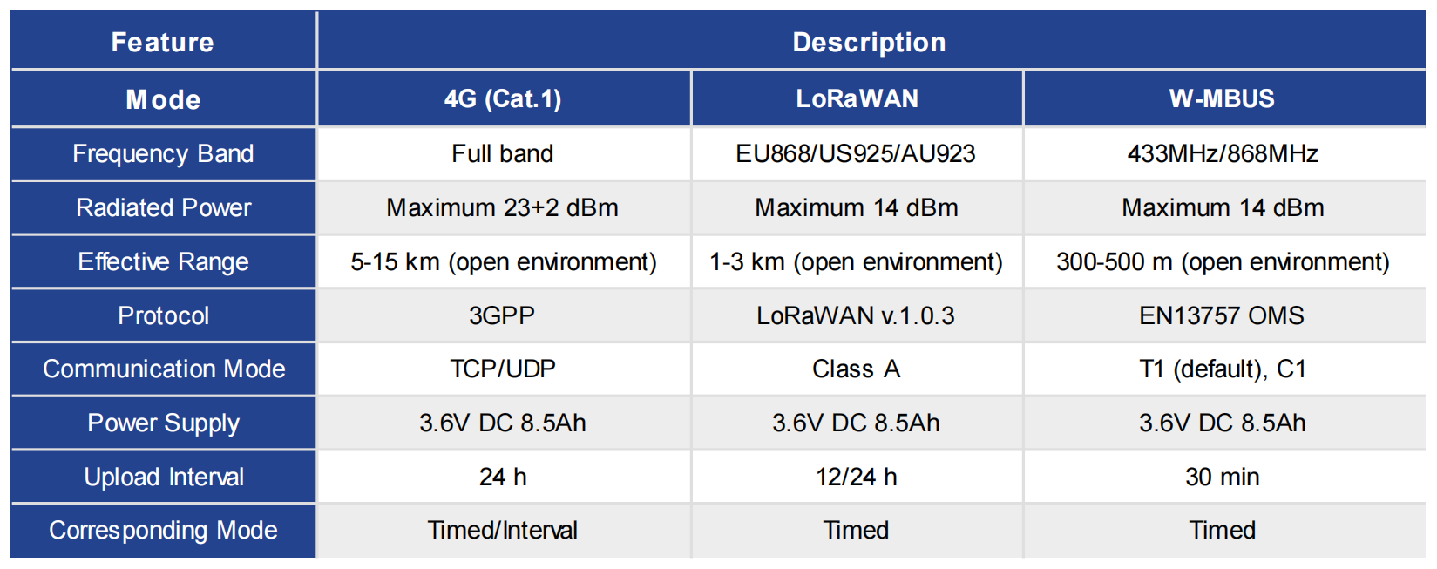

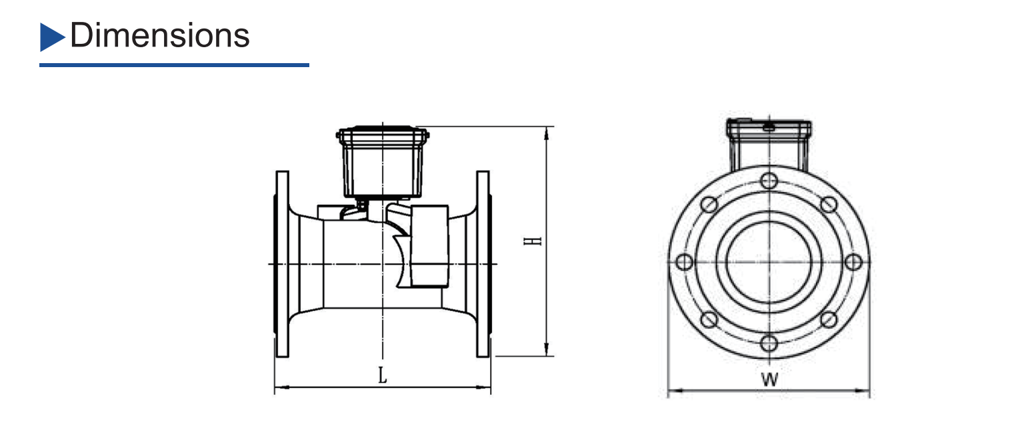
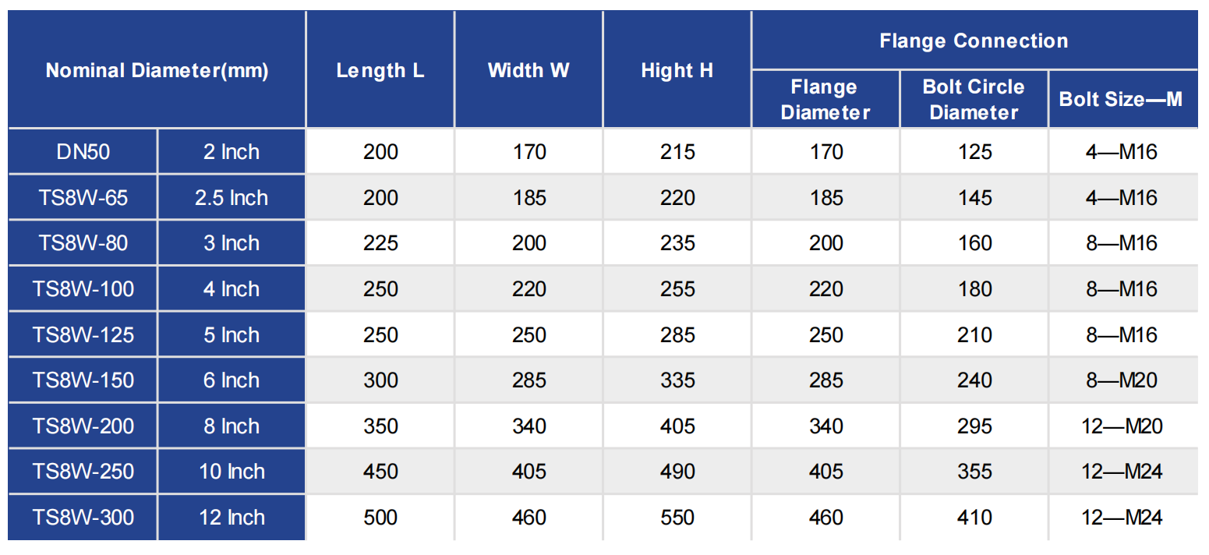

Legal Notice & Disclaimer
This document is prepared by Lianyungang Weizidom Group Electronic Technology Co., Ltd. (hereinafter referred to as “Weizidom Group Metering”) for the purpose of providing potential customers with technical information regarding our products and solutions. All readers are hereby advised and agree to the following terms:
Dynamic Nature of Technical Specifications
Weizidom Group Metering reserves the right to continuously iterate and optimize product hardware designs, software algorithms, system architectures, and technical parameters. Such modifications may be implemented without prior notice. All technical specifications, performance indicators, and functional descriptions contained herein represent the state of technology at the time of publication and do not constitute a final commitment to delivery. The definitive terms shall be governed exclusively by the formal Technical Agreement and Product Delivery List executed between the parties.
Applicability of Performance Data
All performance data and test results cited in this document are based on values obtained from testing conducted by Weizidom Group Metering under standard laboratory conditions. Actual system performance in a deployed environment may vary due to factors such as the complexity of the on-site environment, network topology, and the degree of integration with third-party systems. Weizidom Group Metering makes no warranties or representations regarding the performance of its products in specific, non-standard environments.
System Compatibility and Integration
The compatibility of Weizidom Group Metering’s software systems with third-party platforms or devices is subject to the officially published compatibility certification list. For integration solutions not included on this list, Weizidom Group Metering provides no technical support or guarantees of stability. Customers are responsible for conducting thorough compatibility testing prior to undertaking any system integration.
Intellectual Property Rights
The entire content of this document, including but not limited to technical solutions, architectural diagrams, code snippets, and textual descriptions, is the exclusive intellectual property of Weizidom Group Metering. Any disclosure, reproduction, or use for commercial purposes to any third party is strictly prohibited without the express written authorization of Weizidom Group Metering.


WEIZIDOM GROUP
www.wsdvalves.com
South City, Longhu Town, Xinzheng City,
Zhengzhou City, Henan Province, China

